LEARNING ACTIVITY 4 · BRIEF REPORT

Modeling and Commercial Strategy – North Quay Gifts
Russel Emmanuel Ku Aguilar (2309131) · Damian Nicolas Sanchez Novelo (2109134) · Jonathan Abisai Velasco Martín (2309060) · Ángel Rivaldo Canché Chuc (2309030) · Bianca Alexandra Acosta Castellanos (2309001)
Universidad Politécnica de Yucatán · Prof. Didier Omar Gamboa Angulo · November 3, 2026
Scope. All monetary figures follow Route B (Activity 2): sales net of recorded credits, in GBP; they are not profit. The case history ends on December 9, 2011, so every forecast period is future only relative to that history. The repurchase model is a July 2011 snapshot; the RFM segments use data up to December 2011. They are two different pictures and are not combined. The analysis follows the team’s project focus defined in A3.2 Business Understanding (net customer value adjusted for cancellations). Full code, parameters and outputs are in the notebook “NB5 Modeling and Commercial Strategy - Online Retail II.ipynb” (seed 42).

1. Priority recommendation
Run a randomized reactivation pilot before scaling any customer campaign. The tree model identifies 77.6% of the customers who will not repurchase within 90 days (Recall 0, test set). The clearest at-risk profile, customers who have not bought for 101–157 days and spent at most £275.60 in the previous 180 days, repurchased at only 23.1%, against 51.7% overall (23.9% on test). We propose contacting the predicted-0 audience (1,411 customers at the July 2011 cutoff) while holding out a random group with no contact.
Indicator. 60-day reactivation rate = customers with at least one valid purchase within 60 days of the contact ÷ customers in the group. The campaign effect is the rate of the contacted group minus the rate of the control group. A high predicted propensity does not prove that an offer causes purchases, so only this comparison can justify scaling the campaign.
In parallel, plan October–December staffing and dispatch at forecast + 10% (+ 15% in November), reviewed weekly, because the model under-forecast the three peak weeks (October 31 – November 20) by 13–17% and the whole test block by 8.3%.

2. Essential evidence

2.1 Daily sales forecast
Target: daily net revenue per observed trading day (604 days; days with no records are not filled with zeros). Forecasts are one step ahead: each one uses only revenue known up to the previous observed day. The last 60 observed days (October 2 – December 9, 2011) were held out as the test block. A linear regression with two lags, recent averages and day of week was selected by time-series cross-validation inside training (CV MAE £7,937 vs £8,145 for the best random forest).
Model (test block, 60 days) | MAE (GBP) | RMSE (GBP) | R² | MAE vs naive
Naive reference: last observed value | £18,360 | £23,954 | -0.73 | —
Linear regression (selected) | £11,451 | £15,580 | 0.27 | -37.6%
Random forest (leaf=5) (not selected) | £10,158 | £14,003 | 0.41 | -44.7%
The random forest does better on test, but it lost in cross-validation; the selection was not changed after seeing the test results.
The selected model has a mean bias of −£4,111 per day and under-forecasts 58% of test days. The two largest errors are Monday 2011-11-14 (actual £111,959, forecast £50,759, −£61,199 ≈ 116 orders at £526 per order) and Wednesday 2011-10-05 (−£35,092). Decision: use the forecast as a daily baseline for staffing and dispatch, planned at forecast + 10% in October–December and + 15% in November, reviewed weekly. Under-forecasting is the costlier error there, because Christmas items cannot be sold after the season. Better inputs would be the wholesale pre-order pipeline, a promotions calendar and more years of history.
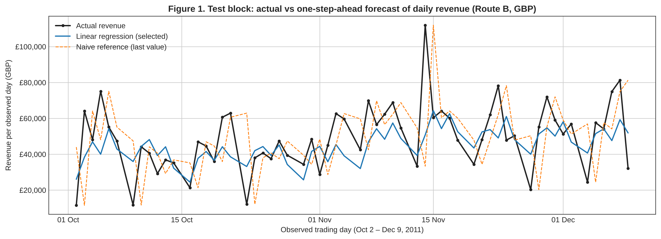
Figure 1. Test block: actual revenue vs selected model and naive reference.

2.2 Repurchase classification (July 2011)
Input: 2,724 customers active between January 2 and June 30, 2011; 51.7% repurchased in the following 90 days. An 80/20 stratified split (seed 42) kept 545 customers for testing. An unbounded initial tree memorized the training data. A bounded search (max_depth 3–5 × min_samples_leaf 20/50/100, 5-fold stratified CV, F1 of class 1) selected depth 4 and leaf 50.
Tree | Set | Accuracy | Precision | Recall | F1
Initial (unbounded) | Train | 1.000 | 1.000 | 1.000 | 1.000
Initial (unbounded) | Test | 0.618 | 0.624 | 0.660 | 0.641
Selected (depth 4, leaf 50) | Train | 0.702 | 0.724 | 0.686 | 0.704
Selected (depth 4, leaf 50) | Test | 0.716 | 0.759 | 0.660 | 0.706
Positive class = 1 (repurchase). The selected tree has similar train and test scores, so it does not overfit.
On the test set the selected tree gives 186 true positives, 59 false positives, 96 false negatives and 204 true negatives. Loyalty audience (predicted 1, Precision 1 = 0.76): 59 of 245 would receive benefits without coming back. Reactivation audience (predicted 0, Precision 0 = 0.68, Recall 0 = 0.78): 96 repurchasers would be contacted needlessly and 59 non-repurchasers would be missed. We accept the unnecessary contacts because a reminder is cheap, while missing at-risk customers loses the purpose of the action.
Rule (complete leaf) | Train n | Train repurchase | Test n | Test repurchase
5+ orders and net spend above £685.93 up to £2,182.20 (loyalty) | 130 | 87.7% | 29 | 93.1%
101–157 days inactive and spend at most £275.60 (reactivation) | 199 | 23.1% | 46 | 23.9%
Class 0 is not definitive churn: 35.1% of July class-0 customers bought again between September 29 and December 9, 2011 (Activity 3).

2.3 RFM segmentation (December 2011)
Input: 5,878 customers with RFM over the full period (reference December 10, 2011). The 41 customers with Monetary ≤ 0 (0.70%; 21 at £0 and 20 negative; −£31,587 in total) cannot be log-transformed. They were set aside for Finance review instead of being made positive. The other 5,837 customers were log-transformed (all three variables are strongly right-skewed) and standardized. K-Means was run for k = 2…8 with k-means++, n_init 10 and seed 42, and the silhouette was computed on all customers. k = 2 has the highest silhouette (0.434) but only separates active from inactive customers. k = 4 (silhouette 0.364, smallest group 19.9%) separates profiles that need opposite actions, so k = 4 was chosen.
Segment | Customers (%) | Median Recency (days) | Median Frequency (orders) | Median Monetary (GBP) | % net revenue
Champions | 1,226 (21.0%) | 17 | 13 | £4,736 | 74.5%
Cooling regulars | 1,523 (26.1%) | 188 | 4 | £1,336 | 16.1%
Recent occasional buyers | 1,159 (19.9%) | 24 | 3 | £725 | 5.8%
Lapsed one-time buyers | 1,929 (33.0%) | 401 | 1 | £254 | 3.6%
Actions to test: Champions – early catalogue access (track the share ordering within 60 days); Cooling regulars – reminder of previously bought items (reactivation rate vs holdout); Recent occasional buyers – cross-sell (% placing another order within 90 days); Lapsed one-time buyers – low-cost win-back only (reactivation rate vs holdout).

2.4 Alignment with our project approach (A3.2 Business Understanding)
Our Business Understanding chose net customer value adjusted for cancellation risk and revenue concentration, for Finance and Commercial Management. Activity 4 answers it in three ways. Concentration: 1,384 customers (23.7%) generate 80% of net revenue. Cancellation risk: 334 customers (5.7%) have at least 10% of their purchases credited (High risk), including 65 Champions with £767,023 of net value and £199,020 credited. Their terms should be reviewed before they receive loyalty budget. Success criterion: A3.2 required a forecast with MAE at least 20% below a simple reference; the daily forecast is 37.6% below it, so the criterion is met at company level.
The file outputs/customer_priority_list.csv ranks the 5,837 segmented customers by net value and shows their segment, credit rate and risk level (Low < 5%, Medium 5–10%, High ≥ 10%; a business rule to review with Finance). It is descriptive, based on net value observed up to December 2011. The customer-level projection of future spending proposed in A3.2 was outside the scope of this activity and is the next step.

3. Main limitations
- Unidentified customers: 22.3% of the lines in the processed file have no Customer ID, so the classification and segmentation describe identified buyers only.
- Short history: only two years of data, so the Q4 seasonality is learned from a single previous season; the forecast lags the peak.
- Propensity ≠ effect: the tree ranks customers by observed repurchase; only a randomized pilot can measure what a campaign causes.
- No costs: Revenue is net sales, not profit; no ROI or profitability is claimed for any action.
- Different snapshots: July classification and December segments are not combined or applied retrospectively.
Deliverables in A-3-6_ModelingStrategy: the executed notebook, “Activity 4. Executive Presentation.pptx” (three decisions for management, with a technical appendix), this report, and outputs/ (resultados_actividad4.json, forecast_test_predictions.csv, rfm_segments.csv, customer_priority_list.csv). All figures in the three components come from resultados_actividad4.json.

